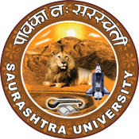

“Independence Day”
Celebrating Aazadi Ka Amritkal

15th August 2023
At
Saurashtra University Campus
Rajkot

Contents
Saurashtra University – IIC 3
Event Schedule 3
Brief about Event 4
Key Points 4
Outcome 5
Connect Us: 8

Saurashtra University – IIC
The university is dedicated to instruction, research, and extending knowledge to the public (public service). Ministry of Education (MoE), Govt. of India has established ‘MoE’s Innovation Cell (MIC)’ to systematically foster the culture of Innovation among all Higher Education Institutions (HEIs). The primary mandate of MIC is to encourage, inspire and nurture young students by supporting them to work with new ideas and transform them into prototypes while they are informative years. Saurashtra University is one the Organization that have constituted the IIC to foster the vision of MoE and be a part for the promotion and development of innovation ecosystem.

Event Schedule

Brief about Event
15th August 2023 - 77th Independence Day was celebrated by SUSEC in collaboration with IIC Saurashtra University. In this day organized programs on the occasion of Independence Day. Honourable Vice Chancellor of Saurashtra University Dr. Girish Bhimani Sir hoisted the flag at Saurashtra University premises. Honourable Vice Chancellor of Saurashtra University congratulated everyone on the 77th Independence Day.
On the occasion of Independence Day, Vice Chancellor of Saurashtra University and Registrar, Dr. Harish Ruparelia Sir offered floral tributes to Sardar Vallabhbhai Patel, Swami Vivekananda, Saraswati Devi and first Vice Chancellor of Saurashtra University Dr. Dolarai Mankad.
Honourable Vice Chancellor of Saurashtra University while addressing the youth on the occasion of the 77th Independence Day celebration said India is a country of youth. Patriotism resides in the soil of India in every particle and in the hearts of the youth. Sir further said that India is becoming a world guru. India has reached the heights of success of Chandrayaan-3 by becoming self-sufficient in the whole world.
As part of the "Meri Mitti, Mera Desh" campaign, about 600 students and employees took the "Panchaprana Pledge" at the Saurashtra University campus on the occasion of Independence Day celebrations. Students of Saurashtra University performed pyramid dance on patriotic songs of of the nation. A student of Saurashtra University sang a patriotic song on the occasion of 77th Independence Day celebrations. Honourable Vice Chancellor, Registrar and the students of Saurashtra University "Vasudhavandan" (tree planting) was done in the grounds of Human Rights Bhavan by students.
As many as 7000 students of Saurashtra University buildings and affiliated colleges enthusiastically participated in the "Tiranga Yatra" organized as part of Independence Day celebrations in Rajkot.

Key Points
During the session, below mentioned points were discussed:
- Significance of Independence Day
- Interesting Facts About Independence Day
- "Meri Mitti, Mera Desh" campaign
- Tree Plantation
- Tiranga Yatra
- Independence Day is the most important day in the history of India

Outcome
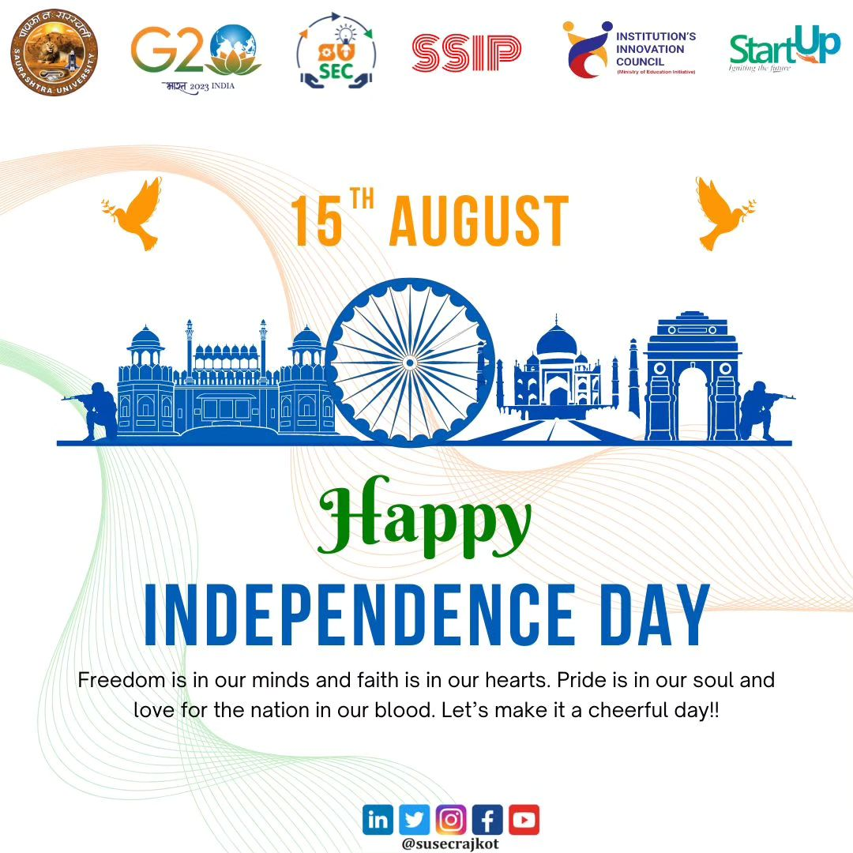
Each year on 15th August we celebrate the day we became an independent nation, which means we were free to rule ourselves and were not ruled. Independence Day is an annual commemoration to celebrate the historic achievement of India to gain freedom from the British empire. The country became officially freed after years of struggle and sacrifices against British rule. Independence Day celebrated on 15th August, is a significant national day in India. It marks the day when the country gained independence from British rule in 1947. This day reminds us of the sacrifices and courage all men and women took to free our country from the Britishers. The country became officially freed after years of struggle and sacrifices against British rule.

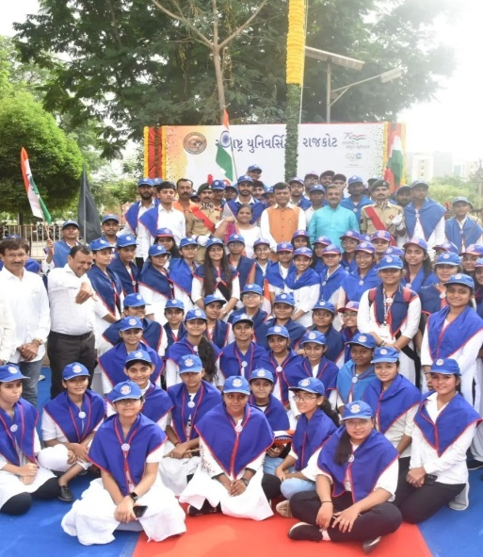
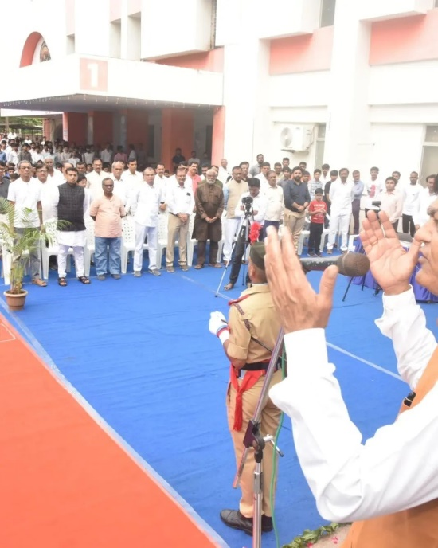
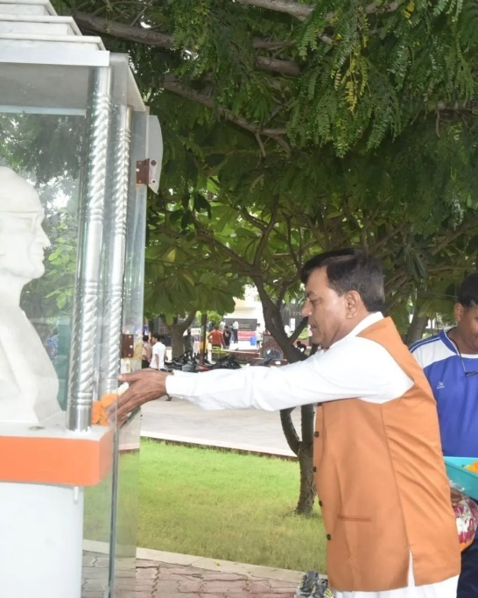
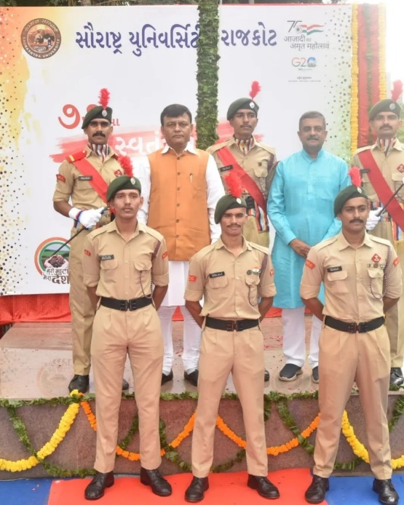
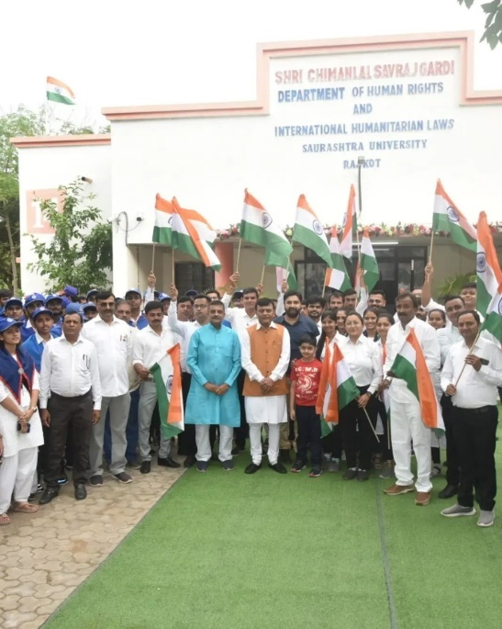
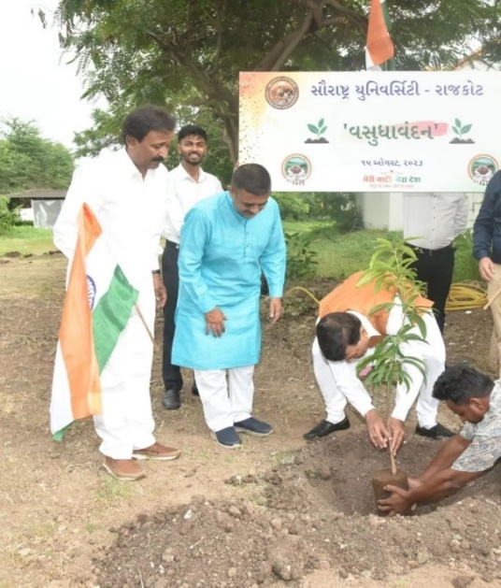
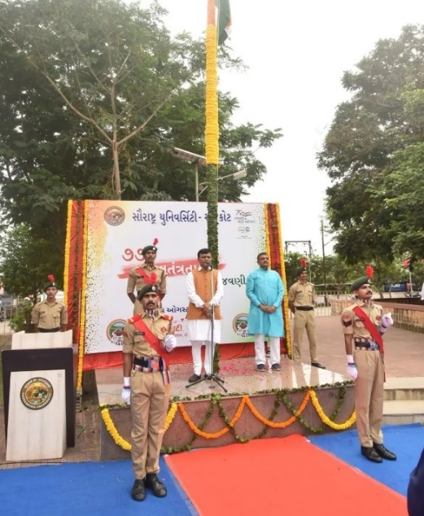
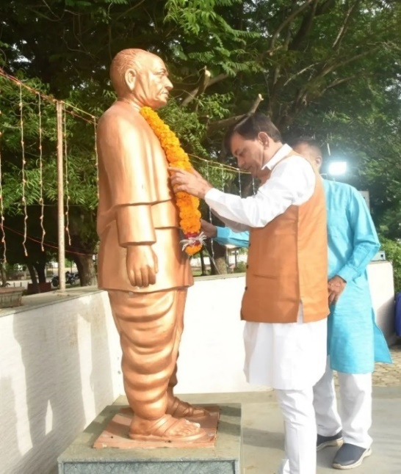
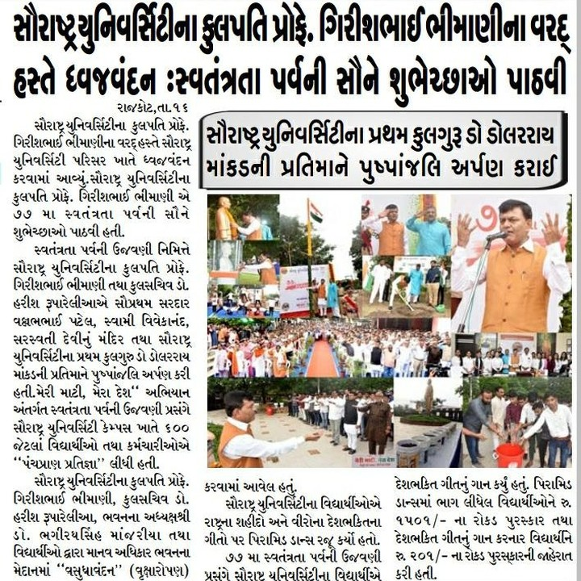
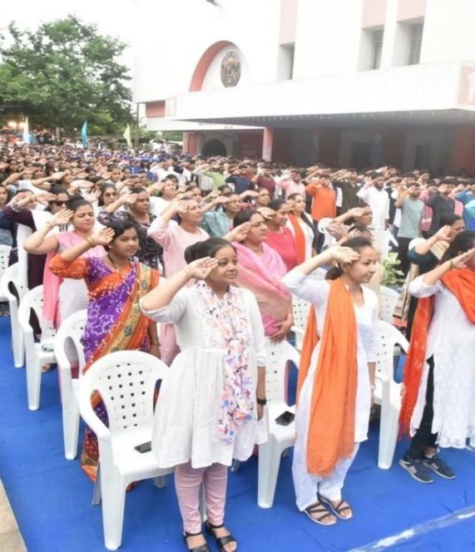

Connect Us:
https://www.linkedin.com/company/susec iic@sauuni.ac.in
https://www.facebook.com/iicsauuni https://bit.ly/SUSECLocation
https://www.instagram.com/susecrajkot https://bit.ly/SUSEC-youtube

